Time recording with ClickTime

Internal information

Start ClickTime
ClickTime can be started from any browser. On a Windows PC, Mac, tablet or smart phone.

It can be called up at https://login2.clicktime.ch

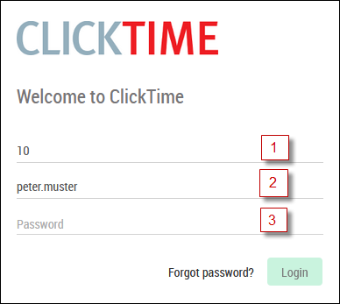

- Company number (valid for all employees in a company)
- User name: as specified by the company
- Password (at least 8 characters, upper and lower case letters, numbers)

Personal settings

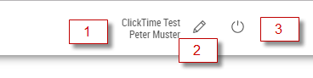

- The company name and user are shown in the top right.
- The personal password can be changed here.
- You can log off from ClickTime here.

Time recording
- The view always comprises one week. You can scroll backwards and forwards by one week with the two arrows. Click the calendar page to jump to any week.
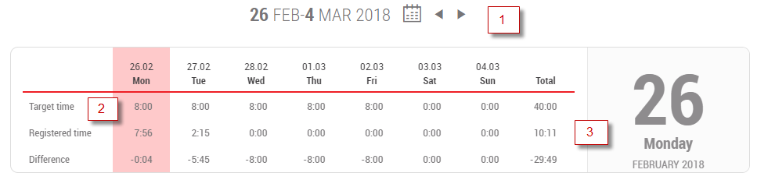

- The target time shows the working hours per day. This depends on the time recording mode that has been chosen and the level of employment that has been saved. Whole public holidays or reduced working days are taken into account automatically.
- This row shows all of the recorded hours.
- All recorded times are shown in the daily overview with all of the details. The origin of the recording is shown under T. PC=browser, A=mobile App, T=terminal, B1/2=break corrections, S=Interface.

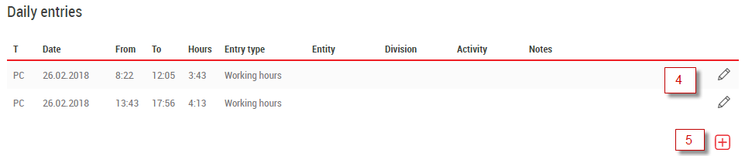

- The Plus symbol is used to create a new entry.

Create a new entry
Creating an entry comprises not only the type of entry but also projects, areas or activities depending on the settings.

Comments can contain smaller or larger explanations.

The working hours are often shown as from and to times. Absences are normally only recorded by entering the number of hours.

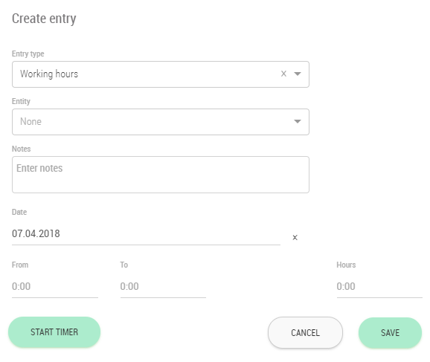

There are basically 4 ways to enter the time:
- After entering the entry type, you start the timer. This creates an entry with the current time. This is mainly used for normal working hours.
- If the work has already started earlier, you can enter the "from time" and start the timer. This creates an entry for the entered time.
- You directly enter the "from time" and the "to time" and press Save. This creates a complete time entry.
- You only enter the hours and press Save. This is mainly used for absences.

Entries with timer
For entries with timer the daily entry appears as follows:

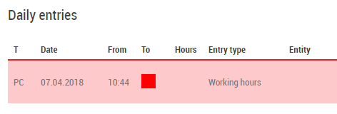

When you finish the work or have a break, just press the stop button, then the "to-time" is entered.

Quick entry
You can create your own templates under quick entry. These can contain the type, times, hours, comments, etc. as required. Click on a template to open this and add information as required or save directly as a record.

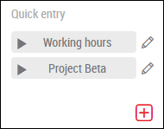

For recording types in the work or overtime category, an additional start arrow appears, with which a new entry is started directly.

Annual overview
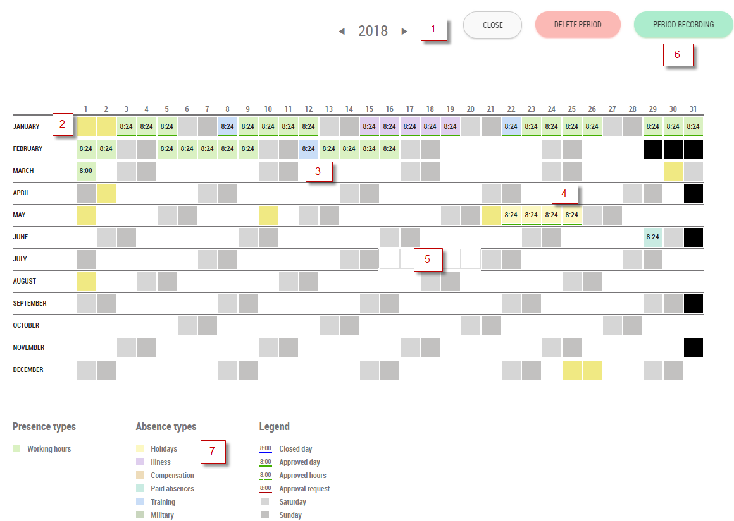

- Change between years using the arrows.
- Public holidays are shown in colour.
- The recorded times appear for every day with the corresponding colour of the type. Two colours appear if more than one type has been recorded. If the month is underlined in green, the entire month has been initialled and approved.
- Absences such as holidays can also be approved in advance and are then blocked for the employee.
- If several days are to be recorded, e.g. for holidays, the days can be selected with the mouse and left arrow key so that period recording is then opened.
- Period recording can also be selected directly here.
- The key shows the different types of recording that are possible with the colours.
- If necessary, a period of entries can also be deleted if it is not approved or is part of a request.

Period recording
The following selection screen appears after the days have been selected in the annual overview or period recording has been clicked:
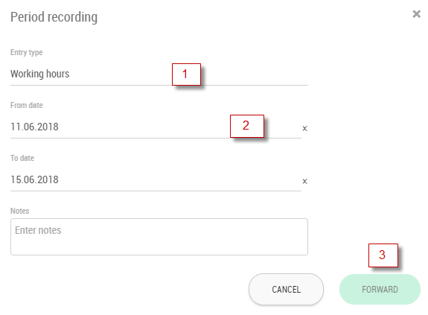
- Select the type of recording here.
- Days will be shown if they have already been selected. The date fields are otherwise empty and can be selected.
- If you are unable to progress any further here this is most likely because the selected type cannot be recorded in the future.
The days that have been recorded are shown in the next step.
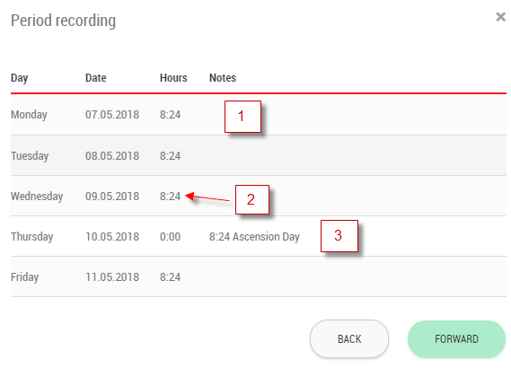
- The number of hours are taken over from the target times depending on the employment.
- The hours can be altered if necessary.
- No hours, or at most reduced hours, are entered on public holidays.

Daily balances
Yesterday's balances are displayed on the right side of the weekly overview. If you move the mouse over a balance value, more information about the corresponding balance will be displayed.

A traffic light system is provided for flexitime. If a first value is exceeded, the value is displayed in orange. If the second value is exceeded, it then turns red.
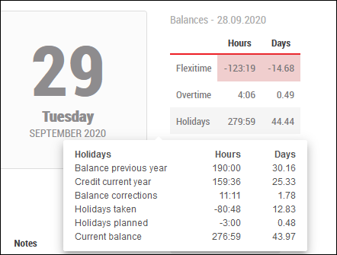

Monthly report (Information menu)
In the monthly report, all recorded entries are listed and at the end of the report the balances from the end of the month are shown.
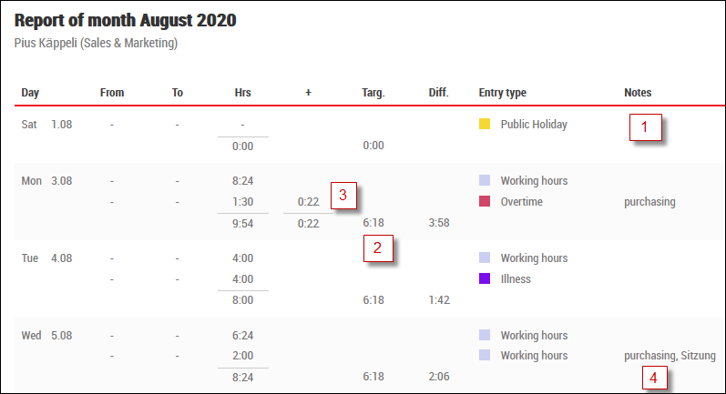

- The public holidays are displayed for information.
- The calculated target time is displayed every day.
- If hours are recorded with surcharges, the surcharges are displayed separately.
- If remarks, projects or cost centres are entered, they are displayed under remarks.

Annual report (Information menu)
The annual report provides an overview of the hours, target times and balances per month.

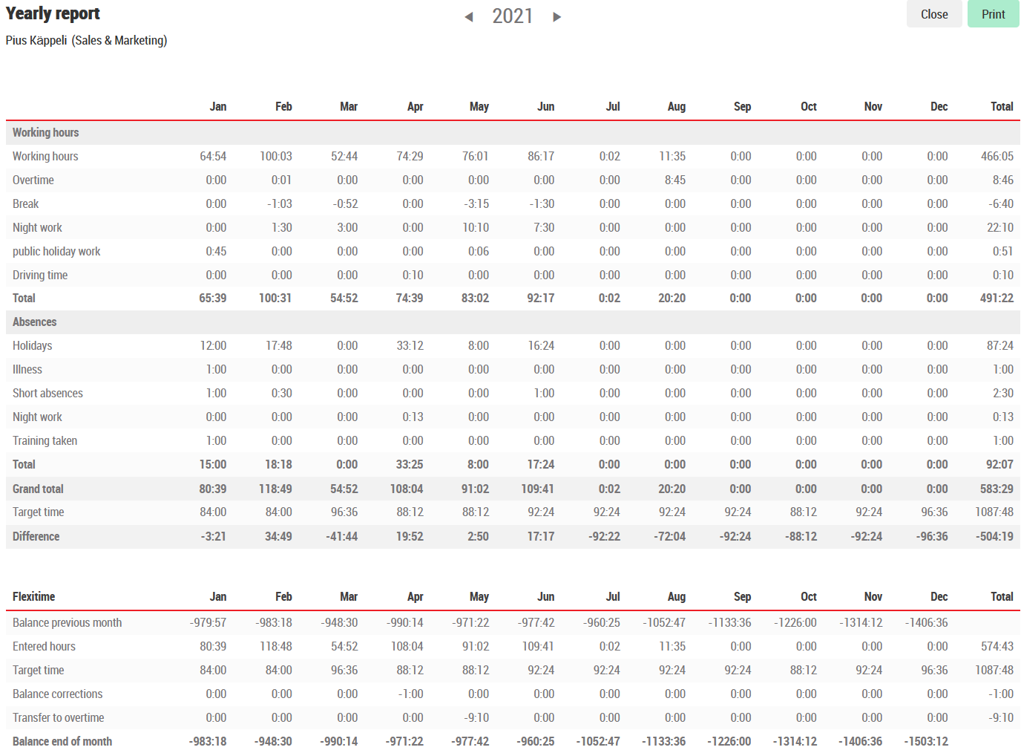

Holiday overview (Information menu)
In the holiday overview the holidays or other absences of the own department or the whole company can be displayed.

In this way, absences can be mutually coordinated and provide information about planned absences.

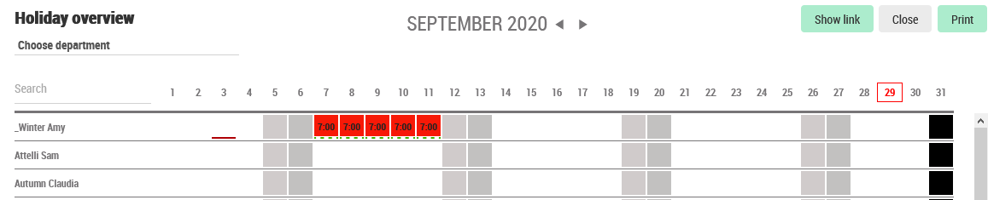

Evaluating own projects (Information menu)
If project recording is used, the employee can evaluate his personal hours per project.
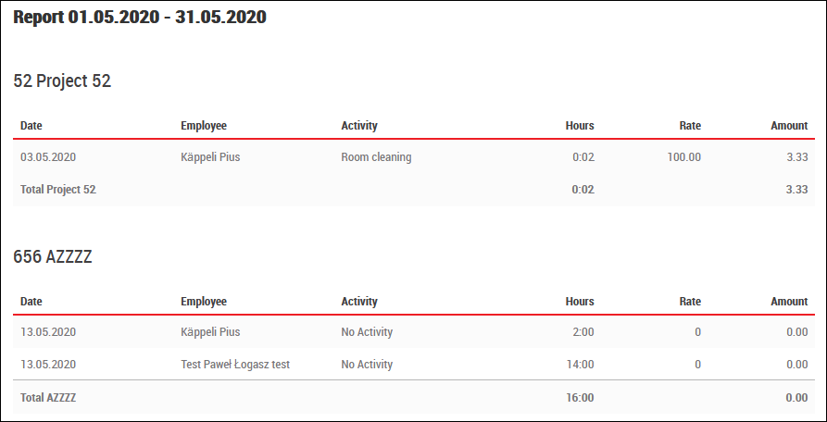

Display team planning (Information menu)
If shift planning is used, the employee can view or print out the team plan in which he or she is scheduled.

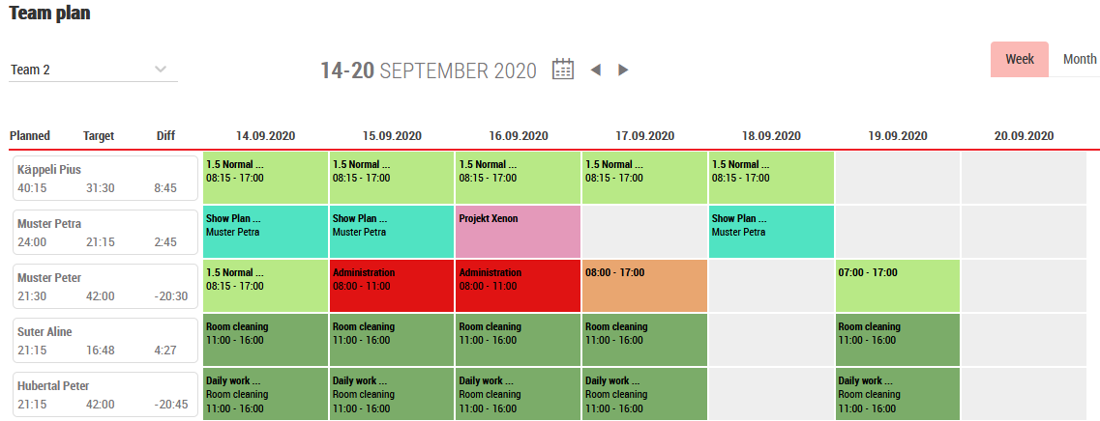

The same plan is also displayed in the Mobile App.

